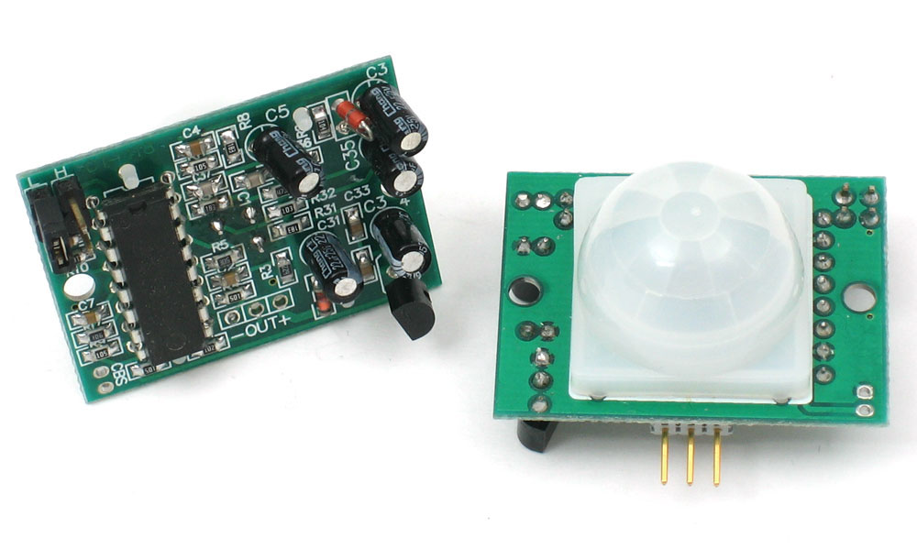
PIR SENSOR INFORMATION

Working Principle:
  - PIR sensors work based on the principle that all objects with a temperature above absolute zero emit infrared radiation.
  - The sensor consists of a pyroelectric material, which generates a voltage when exposed to changes in IR radiation.
Detection Range:
  - PIR sensors have a specific detection range, typically represented in terms of distance and angle.
  - The detection range depends on factors such as the sensor's design and the sensitivity settings.
Field of View (FOV):
  - PIR sensors have a defined field of view, which is the area that the sensor can monitor for infrared radiation.
  - Adjusting the lens or placement of the sensor can affect the field of view.
Two-Element and Four-Element Sensors:
  - PIR sensors can be two-element or four-element devices. Four-element sensors are more advanced and can provide better detection performance.
Application in Motion Detection:
  - PIR sensors are commonly used for motion detection in security systems and lighting controls.
  - When a person or object moves within the sensor's field of view, there is a change in the infrared radiation detected, triggering the sensor.
False Alarms:
  - PIR sensors are sensitive to temperature changes, and factors like moving curtains, pets, or changes in sunlight can sometimes lead to false alarms.
  - Sensitivity and time delay settings can be adjusted to minimize false alarms.
Power Consumption:
  - PIR sensors are known for their low power consumption, making them suitable for battery-powered devices.
Integration with Other Systems:
  - PIR sensors are often integrated into larger systems, such as security alarms, smart home automation, and energy-efficient lighting systems.

Outdoor and Indoor Use:
  - PIR sensors are available for both indoor and outdoor use, with outdoor sensors typically designed to be weatherproof.
Usage in Smart Home Devices:
  - PIR sensors are commonly found in smart home devices for automation, such as turning on lights when motion is detected or adjusting thermostats based on occupancy.
When using PIR sensors, it's essential to understand the specific requirements of the application and adjust sensitivity and other settings accordingly to achieve optimal performance.

